#### URL to website: <http://web.engr.oregonstate.edu/~tsengt/CS340/index.html>

#### Feedback by the peer reviewers

# Review 1:

# 1. Are the attributes for each entity in the ERD same as that described in the database outline?

# Yes, all attributes are listed correctly.

# 2. Is the participation of entities in the relationships same as that described in the outline?

# Maybe, the description of how posts will work seems a little vague but can be interpreted the same way as the diagram. However, I dont think this was intended, currently the diagram shows that every post must have a picture and a video. I think the intended relationship is at least one of either is required.

# 3. Is the cardinality of entities in the relationships same as that described in the outline?

# Yes.

# 4. Based on the Database outline, could any of the relationships be better off described as an Entity instead ?

# I think the relationship between posts, videos, and pictures would be clearer if an entity was added into the mix. Maybe something like content entity that is related to videos, pictures and posts, this could simplify the ternary relationship.

# 5. Is there something that could be changed/improved in the E R Diagram and/or the overall database design?

# The relationship between users and posts is somewhat unclear. How will a post be related to one user? The post doesn’t contain a user ID attribute or anything to signify its related to a user. This issue is also present in every relationship between entities, they are related to one another but have no way of knowing what they are related to. I.e. a post knows how many videos it has, but there is nothing linking that post to any of the videos, so in my mind the post would just say 3 videos, with no more information about the videos.

# Schema:

# 1. Are the relationship tables present where required and correctly defined, when compared with the database outline?

# No, the schema has extra attributes that represent the Id’s of other entities that are used in the relationships. This in my opinion is correct, and should actually be applied to most of the entities in the DB. The outline does not mention that keys of other entity being stored as attributes or being used in the relationships.

# 2. Are foreign keys present where required and correctly defined, when compared with the database outline?

# No. The outline doesn’t mention storing foreign keys however the schema does store some. I think the way the schema is represented is correct and the outline should be changed to match the schema.

# 3. Do the entity attributes match those described in the outline?

# Yes, other than the keys.

# 4. Is there something that could be changed/improved in the Schema and/or the overall database design?

# As previously mentioned, I think having entities contain foreign keys will go a long way to adding the intended functionality to the DB.

# 

# Review 2:

# Are the attributes for each entity in the ERD same as that described in the database outline? Yes

# Is the participation of entities in the relationships same as that described in the outline? Yes

# Is the cardinality of entities in the relationships same as that described in the outline? Yes

# Based on the Database outline, could any of the relationships be better off described as an Entity instead ? Nope

# Is there something that could be changed/improved in the E R Diagram and/or the overall database design? Nothing that would really help the design, but if you moved the Post entity to the center of the diagram you could remove all the line overlap.

# The best peer review for a Schema would answer all of the following questions:

# 

# Are the relationship tables present where required and correctly defined, when compared with the database outline? Yes

# Are foreign keys present where required and correctly defined, when compared with the database outline? Well, they are defined in the Schema but not mentioned in the outline.

# Do the entity attributes match those described in the outline? Yup

# Is there something that could be changed/improved in the Schema and/or the overall database design? I think it looks pretty good, just go change the outline to indicate which attributes should be the primary keys

# 

# 

# 

# Review 3:

# Are the attributes for each entity in the ERD same as that described in the database outline? Yes

# Is the participation of entities in the relationships same as that described in the outline? Yes

# Is the cardinality of entities in the relationships same as that described in the outline? Yes

# Based on the Database outline, could any of the relationships be better off described as an Entity instead ? No

# Is there something that could be changed/improved in the E R Diagram and/or the overall database design? Rearranging the ER diagram a bit could make it more visually appealing and easier to understand.

# The best peer review for a Schema would answer all of the following questions:

# 

# Are the relationship tables present where required and correctly defined, when compared with the database outline? Yes

# Are foreign keys present where required and correctly defined, when compared with the database outline? Foreign keys aren't defined in the outline. Schema looks good though.

# Do the entity attributes match those described in the outline? Yes

# Is there something that could be changed/improved in the Schema and/or the overall database design? Everything looks good. Although I think you should redesign your Database Outline as an actual outline, as opposed to several small paragraphs

# Review 4:

# Are the attributes for each entity in the ERD same as that described in the database outline? Yes

# Is the participation of entities in the relationships same as that described in the outline? Yes

# Is the cardinality of entities in the relationships same as that described in the outline? Yes

# Based on the Database outline, could any of the relationships be better off described as an Entity instead ? Yes

# Is there something that could be changed/improved in the E R Diagram and/or the overall database design? Maybe it's a good idea to improve the visibility of the ERD diagram, especially for each entity.

# Are the relationship tables present where required and correctly defined, when compared with the database outline? Yes

# Are foreign keys present where required and correctly defined, when compared with the database outline? Yes

# Do the entity attributes match those described in the outline? Yes

# Is there something that could be changed/improved in the Schema and/or the overall database design? The schema looks good

#### Actions based on the feedback

Change the outline to match the schema with foreign keys. Mention foreign keys in the outline.

Which attributes are primany keys in the outline

Move post to center of ED diagram

#### Upgrades to the Draft version

# Changed the ED diagram to look more aesthetically pleasing.

Changed our outline to be easier to read

Matched our Database Outline to match our Schema

* Showed which of the Attributes were keys, and added foriegn keys that were in the schema, but not in the outline.

# Fixes

Based on feedback we added the ‘type’ of each attribute to our outline.

We felt that having a flagged / reports attribute was redundant, instead we will simple use # of reports/

# Database Outline

For our project, our idea for implementing a database into a website is to develop a website where users can like and comment on a variety of pictures and videos (a combination of imgur / youtube). Users will then be able to comment on the posts.. users will be able to also ‘like’ a comment.

Users will also be able to search posts, pictures, videos and even comments based on different attributes (see below).

***Entities:*** ​User, Pictures, Posts, Videos, Comments, Likes (comments)

***‘User’ Attributes:***​

​User ID (string), primary key),

Join date(int),

Male or Female [M/F] (char),

Age (int),

Post count (int),

Premium?

(bool) # of times reported (int)

***‘Picture’ Attributes:***​​

Picture ID (int, primary key),

Category (string),

Date posted (int),

# of likes (int),

# of views (int)​*,*

*‘*​***Video’ Attributes:***

​Video ID (int, primary key),

Category (string),

Date posted (int),

Length (int),

Quality (360p etc..) (int)

#of views (int),

***‘Post’ Attributes:***

​Post ID(int, primary key),

User ID(string, foriegn key),

Title(string),

# of Items(int),

# of comments(int),

# of views (int),

reports(int)

***‘Comment’ Attributes***​: Comment ID (int, primary key),

user ID (foriegn key),

number of likes,

date (int),

reports (int),

***Relationships:***

A user can like multiple posts, and a post can be liked by multiple people (many to many)

A user can like multiple comments and a comment can be liked by multiple people A user has zero to many posts.

A post can only have one user.

A post can have zero to many likes A post can have zero to many comments.

A comment can have zero to many likes.

A comment can only be associated to one post

A comment is associated to only one use

A post has at least one or many pictures / videos while a picture or video can only be associated with one post.

A picture is associated with only one post

A video is associated with only one post

# Relationship Diagram

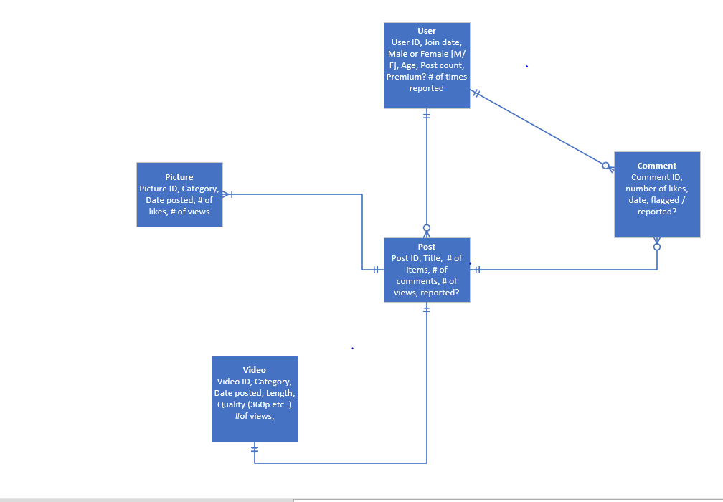

# Schema

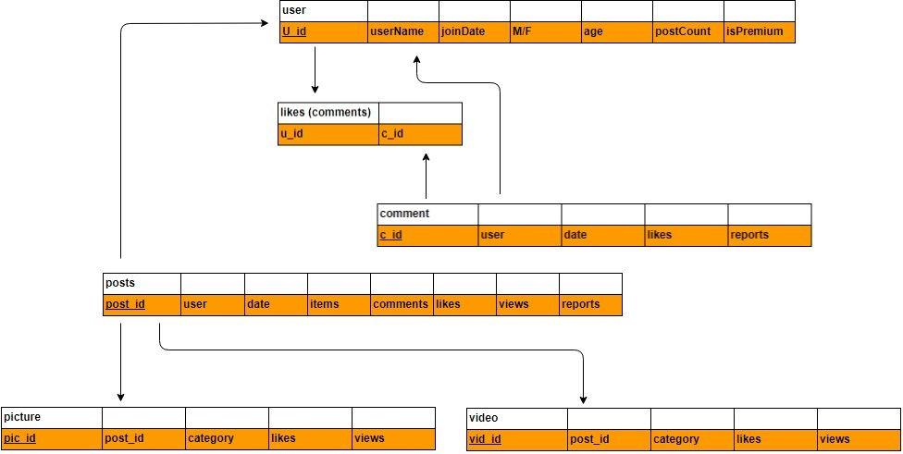

**Feedback**

**Data Manipulation Queries**

Missing the DELETE queries

**HTML Page**

Missing implementation of DELETE function.

HTML is unfinished

Use a list for delete function

**DDQ File**

Assignment of foreign keys to tables that are not created.